Code Breakers – Escape room game – Game Design Document

Purpose:
This game design document is being created to create a concise goal for the Code Breakers Escape Room game for the clients, Data Education in Schools (Learning with Data - Data Education in Schools) for the Group Project Module.
After meeting with the clients, the product is likely to be an online game for students aged between 9 and 14, throughout different years of primary and secondary school. As well as an online aspect for the game, a printed-out paper to accompany the game was discussed.
Gameplay:
The core gameplay of the online game will be for the students to use data to solve a set number of puzzles to complete the overall scenario. As this is a work in progress, the number of puzzles and the content is subject to change.
Goals:
The goal of the game is to empower students to handle data in a responsible and problem-solving way, to allow for completion of the puzzle tasks within the game. Once the students have solved a set number of puzzles, the final puzzle will unlock, and they will be able to complete the final task to “complete the mission” (Subject to change).

Game World:
The game world is set in real life, using real world statistics and data to solve problems, although the characters are fictitious. The antagonists of the players are the V.I.K.I.N.G.S, (Villains, Insurgents and Kleptomaniacs: Invading Networks and Global Systems) and the students are tasked as a new trainee of D.A.T.A (Defence, Against, Temporal, Attacks) by the fictitious Major X to stop the Vikings from data crimes. These data crimes include real world threats, such as, breaking into databases, spreading fake news and spreading computer viruses. This information is shown in a secret agent style dossier, signed by the character Major X. This gives the player a clear goal as to what is expected of them and a personal stake in completing their mission.
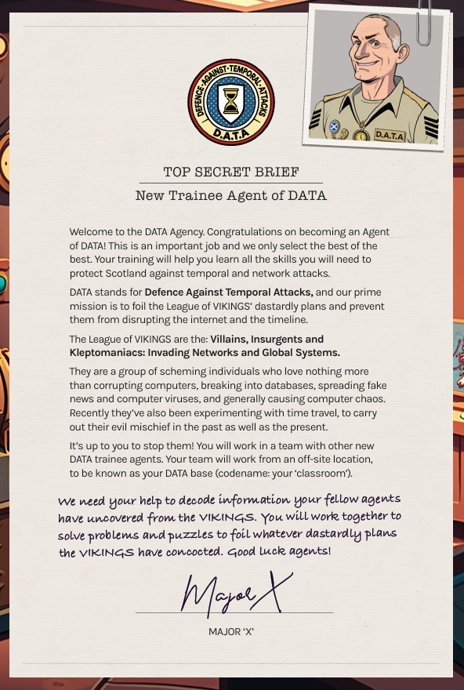
Data Schools Education, Top Secret Brief, 2023
This information is from the 2023 version of the online game, and although the details of the characters can remain the same, or similar, the puzzles will be different, and the overall mission statement will be changed.
Students will be able to enter their own “Agent Name” as a username, which can be used to keep track of progress of the puzzles, without the need for any real personal data to be saved. Allowing the student to choose their own name allows for creativity and personalisation, which in turn should have the student engage more with the online game as they will be fully roleplaying as the trainee DATA agent that they have created.

Puzzles:
There will be between 5 and 7 different puzzles that the students will have to work through to complete the scenario successfully. The students can complete any of the puzzles in any order, and some of the puzzles will be randomised with four different solutions to allow for students to have similar, but different experiences and to avoid the issue of students shouting out answers and spoiling any learning experience for others.
For the randomisation, the puzzle could be a simple “Draw with the data points to create lines and complete the picture”, but the picture that needs drawn can change between 3-5 alternates, to stop puzzles being spoilt by others. This randomiser can be implemented during the load process for that specific puzzle (The selected random picture would need to be saved on that users site, in case the student moves off the page and back again.).

Puzzles are currently a work in progress, and all ideas as welcome.

Audio:
There will be basic audio sounds used for navigation purposes throughout the online game, this will allow students to engage further with what their actions are doing in the game. Background music shouldn’t be needed, as this will be loaded by multiple students are different terminals in a classroom, this could be chaotic. There could be background ambiance music for certain levels, such as wind/bird/vehicle sounds to ground the player into that puzzle or scenario, but this should not be a forefront loud piece of sound design, and just to set the scene.

